**Docker Project**

**Multi-Container Flask Application with PostgreSQL Using Docker Compose:**

Step 1: Install the following tools before starting the application.

- Docker

- Docker Compose

Step 2: Check if Docker Compose is available in the system:

-docker-compose version

Step 3: If not installed, install it manually:

-sudo apt install docker-compose

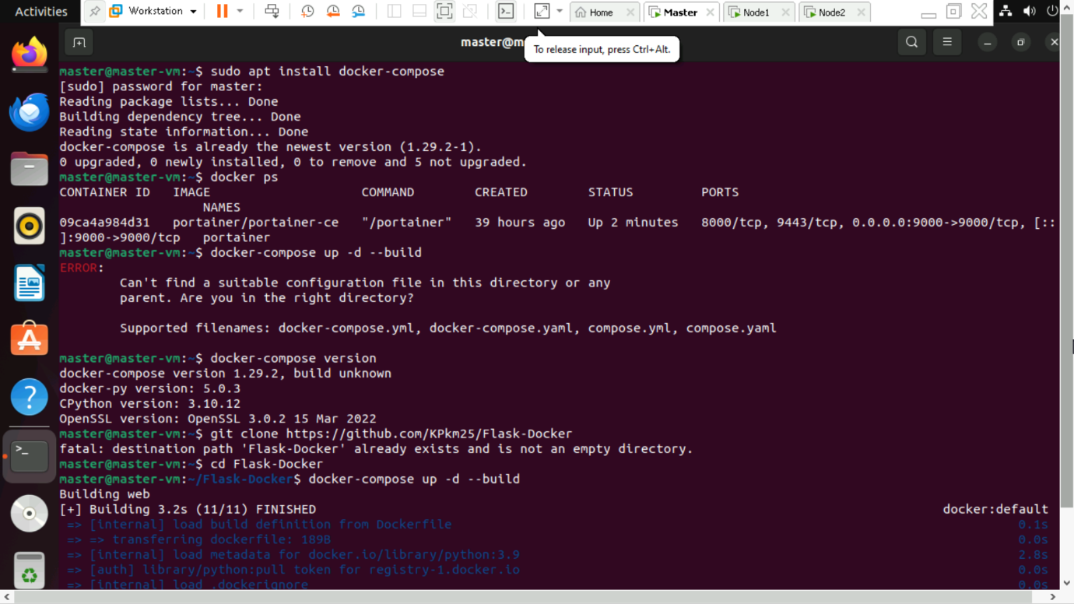

**Setup and Running the Application**

Step 4: Clone the Repository

-git clone <https://github.com/KPkm25/Flask-Docker>

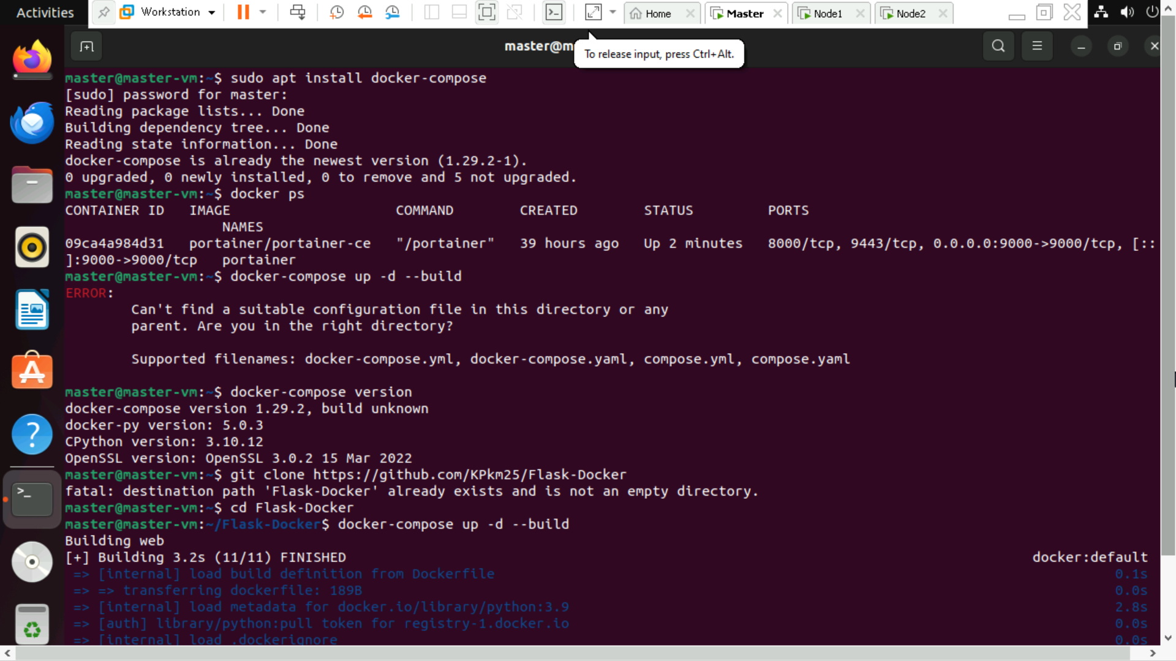

-cd Flask-Docker



Step 5: Build and Start the Containers

-docker-compose up -d –build

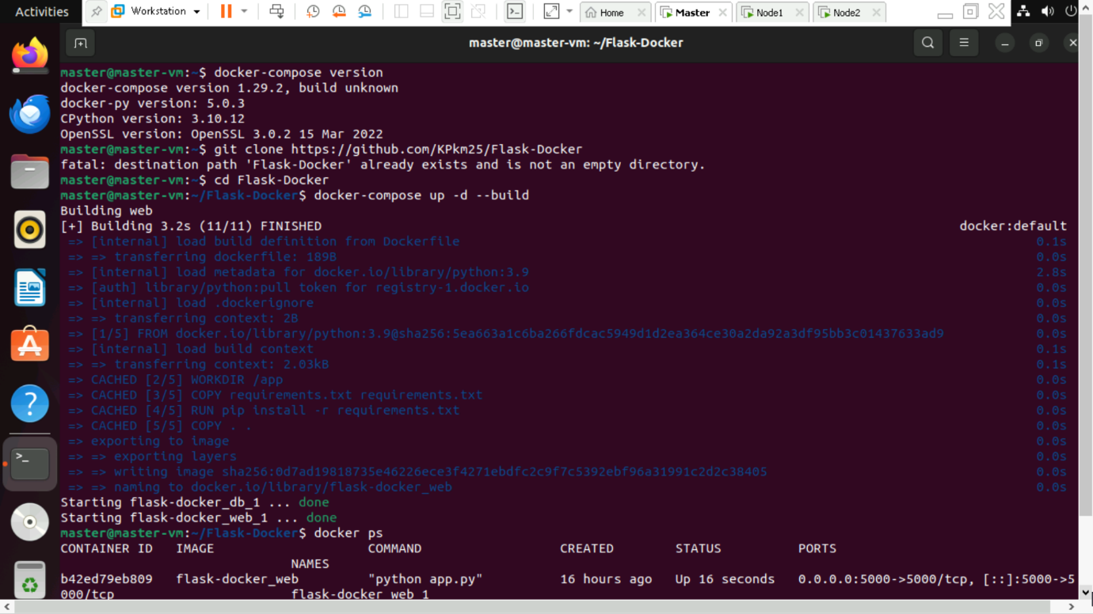

This will:

- Build the Flask application image

- Start the PostgreSQL database container

Step 6: Verify the Running Containers using :

-docker ps

-We will see `web` (Flask app) and `db` (PostgreSQL) services running.

**Step 4: Test the Application**

Open browser or use `curl` to access the endpoints:

- `http://localhost:5000/` → Should output `"Flask App with PostgreSQL!"`

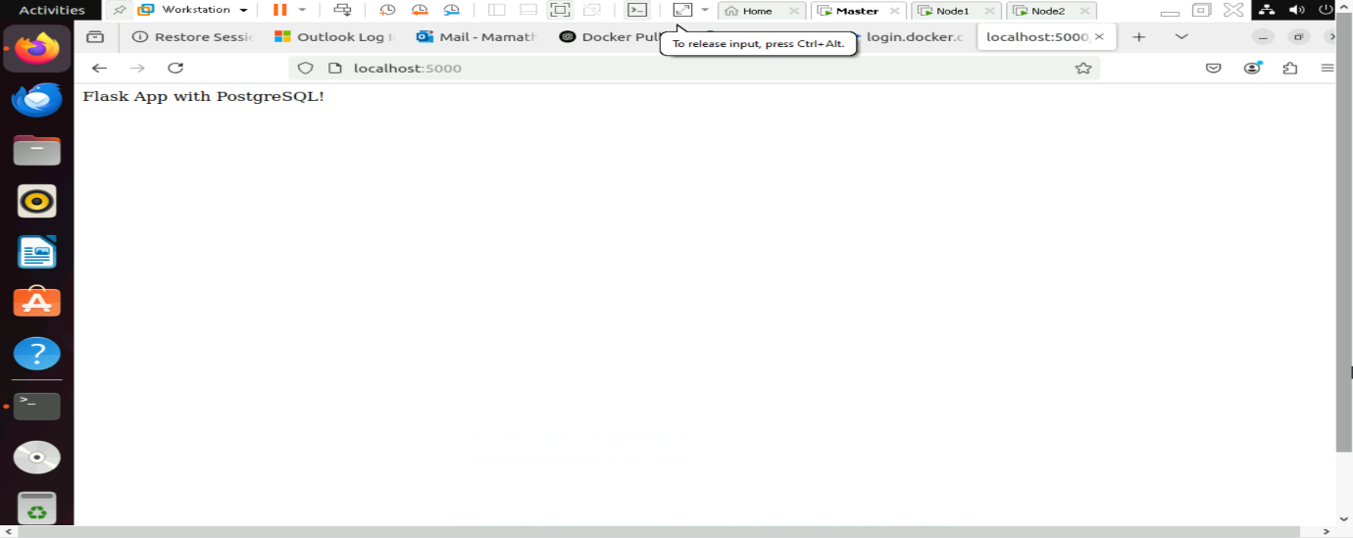

- `http://localhost:5000/db` → Should confirm database connection

